**Assignment -1 Python Programming**

|  |  |
| --- | --- |
| Assignment Date | 19 September 2022 |
| Student Name | Pramoth Kanna P |
| Student Roll Number | CITC1907030 |
| Maximum Marks | 2 Marks |

Question-1: Split this string

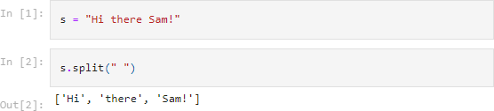

Question-2: Use .format() to print the following string.

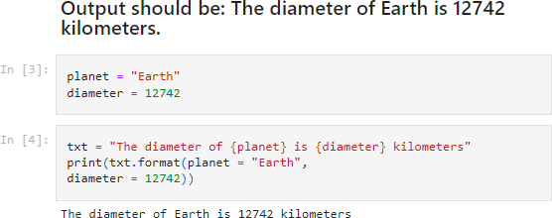

Question-3: In this nest dictionary grab the word "hello"

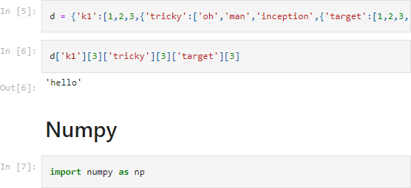

Question-4.1: Create an array of 10 zeros?

Question-4.2: Create an array of 10 fives?

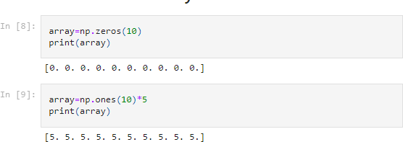

Question-5: Create an array of all the even integers from 20 to 35

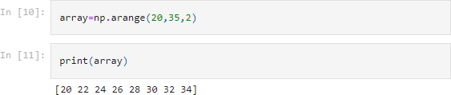

Question-6: Create a 3x3 matrix with values ranging from 0 to 8

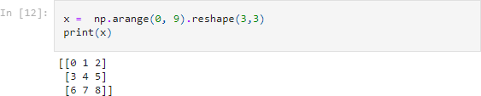

Question-7: Concatenate a and b

a = np.array([1, 2, 3]), b = np.array([4, 5, 6])

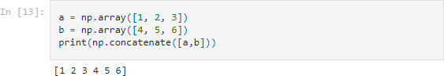

Pandas

Question-8: Create a dataframe with 3 rows and 2 columns

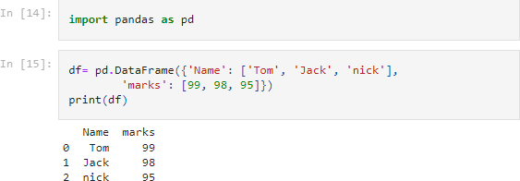

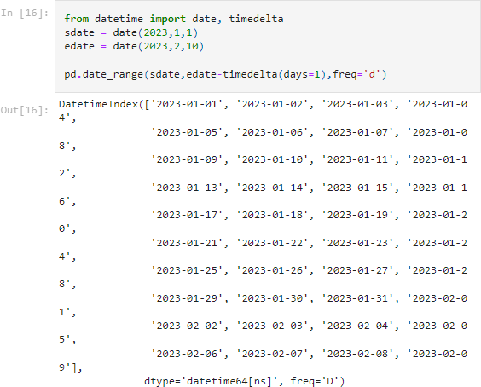Question-9: Generate the series of dates from 1st Jan, 2023 to 10th Feb, 2023

Question-10: Create 2D list to DataFrame

